Golay Nie 1001678015

CSE 5321 Homework 3

Spring 2019

1)

Code description decision table:

|  |  |  |  |  |  |  |  |  |  |
| --- | --- | --- | --- | --- | --- | --- | --- | --- | --- |
|  |  | Rule 1 | Rule 2 | Rule 3 | Rule 4 | Rule 5 | Rule 6 | Rule 7 | Rule 8 |
| Conditions | Member | F | F | F | F | T | T | T | T |
| primeStatus | F | F | T | T | F | F | T | T |
| Cart>=$5,000.00 | F | T | F | T | F | T | F | T |
| Actions | Rate | 0.985 | 0.965 | 0.955 | 0.975 | 0.950 | 0.925 | 0.900 | 0.950 |

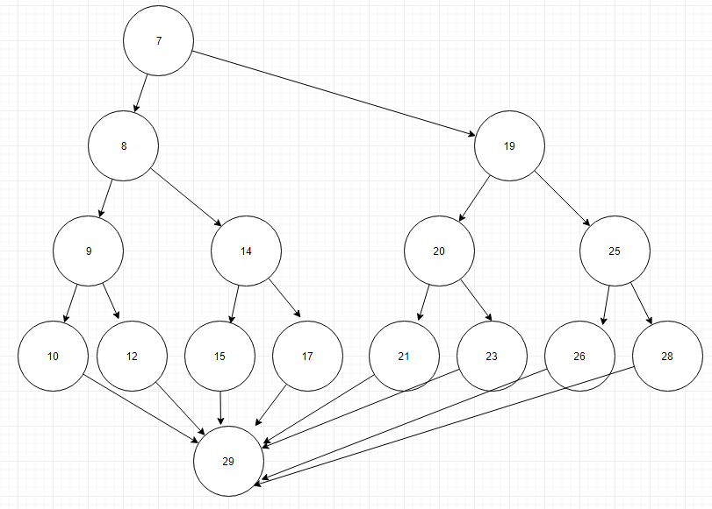

Cyclomatic complexity: 8

|  |  |  |  |  |  |
| --- | --- | --- | --- | --- | --- |
| Test  Case  number | Inputs | | | Exp  Out | Comments |
| member | primeStatus | Cart | Rate |
| 1 | T | T | $5,000.00 | 0.950 | 7-8-9-10-29 |
| 2 | F | T | $5,000.00 | 0.975 | 7-19-20-21-29 |
| 3 | F | F | $5,000.00 | 0.965 | 7-19-25-26-29 |
| 4 | F | F | $4,999.99 | 0.985 | 7-19-25-28-29 |
| 5 | F | T | $4,999.99 | 0.955 | 7-19-20-23-29 |
| 6 | T | F | $4,999.99 | 0.950 | 7-8-14-17-29 |
| 7 | T | F | $5,000.00 | 0.925 | 7-8-14-15-29 |
| 8 | T | T | $4,999.99 | 0.900 | 7-8-9-12-29 |
| 9 | T | T | $0.00 | 0.900 | - |
| 10 | T | T | $10,000.00 | 0.950 | - |

Complete code coverage achieved.

Test case supports description

2)

3)

Decision table implements first-of-rule:

|  |  |  |  |  |  |
| --- | --- | --- | --- | --- | --- |
| we | Rule 1 | Rule 2 | Rule 3 | Rule 4 | Rule 5 |
| **Conditions (ft)** |  |  |  |  |  |
| 400.0<=distance<=1,000.0 | Y |  |  |  |  |
| 95.1<=distance<=399.9 |  | Y |  |  |  |
| 50.0<=distance<=95.0 |  |  | Y |  |  |
| 25.1<=distance<=49.9 |  |  |  | Y |  |
| 0.0<=distance<=25.0 |  |  |  |  | Y |
| **Actions** |  |  |  |  |  |
| greenLight | T | F | F | F | F |
| yellowLight | F | T | T | F | F |
| redLight | F | F | F | T | T |
| Buzzer | F | F | T | T | T |
| brakes | F | F | F | F | T |

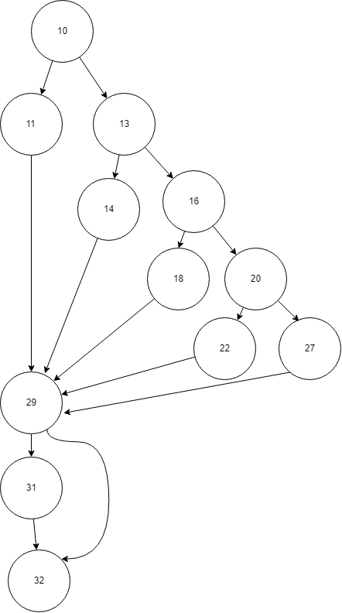

Cyclomatic Complexity: 6

|  |  |  |  |  |  |  |  |  |  |
| --- | --- | --- | --- | --- | --- | --- | --- | --- | --- |
| **Test**  **Case**  **Number** | **Inputs** | | **Exp Out** | | | | | | **Comments** |
| **Distance (ft)** | **count** | **greenLight** | **yellowLight** | **redLight** | **buzzer** | **brakes** | **Count** |
| 1 | 400.0 | 2 | T | F | F | F | F | 0 | 10-11-29-31-32 |
| 2 | 95.1 | 2 | F | T | F | F | F | 0 | 10-13-14-29-31-32 |
| 3 | 50.0 | 2 | F | T | F | T | F | 0 | 10-13-16-18-29-31-32 |
| 4 | 25.1 | 2 | F | F | T | T | F | 0 | 10-13-16-20-22-29-31-32 |
| 5 | 25.0 | 1 | F | F | T | T | F | 0 | 10-13-16-20-27-29-31-32 |
| 6 | 0.0 | 2 | F | F | T | T | T | 3 | 10-13-16-20-27-29-32 |
| 7 | 1,000.0 | 3 | T | F | F | F | F | 3 | - |
| 8 | 399.9 | 3 | F | T | F | F | F | 3 | - |
| 9 | 95.0 | 1 | F | T | F | T | F | 1 | - |
| 10 | 49.9 | 1 | F | F | T | T | F | 1 | - |

Coverage achieved.

Test case supports description.

4)